Technical Report on Power Profile and Performance Metrics for the Airbus A320 aircraft

Dipesh Kunwar1, Yashwanth Kutti Pochareddy2

*1 Energy Systems Er., Nernst Energy System LLP, India, 2 Chief Engineer, CO2 Onboard, Denmark*

# Nomenclature

|  |  |  |
| --- | --- | --- |
| AFM | = | Aircraft Flight Manual |
| AR | = | Aspect Ratio |
| DOF | = | Degree of Freedom |
| ISA | = | International Standard Atmosphere |
| K | = | Induced Drag Correction Factor |
| MLW | = | Maximum Landing Weight |
| MTOW | = | Maximum Takeoff Weight |
| OAT | = | Outside Air Temperature |
| OEW | = | Operational Empty Weight |
| POH | = | Pilot’s Operating Handbook |
| S | = | Planform Area |
| SFC | = | Specific Fuel Consumption |
| $$\text{ρ}$$ | = | Density |

# Introduction

Performance metrics parameterization for any dynamic aircraft systems can help obtain insights on performance requirements for multiple phases of flight. Focusing particularly on the Airbus A320 aircraft, we aim to quantify the performance metric for the entire flight envelope at multiple flight profiles. The formulation developed utilized a low fidelity 2-degree-freedom point calculation to determine the aircraft’s performance metrics. From the obtained performance parameter, we aim to extend the results to our study on the suitability of using alternative propulsion technologies, specifically electrical propulsion, as a replacement to the conventional propulsion systems to obtain similar performance in a single-aisle regional aircraft (similar to that of Airbus A320).

# Performance parameters and Relevant Derivations

The mathematic model developed utilizes standard performance metrics like Maximum Take of Weight (MTOW), Maximum Landing Weight (MLW), Operational Empty Weight (OEW), takeoff distance, landing distance, climb rates, etc. as well as the design specification for the A320 aircraft like Planform area (S), Aspect Ratio (AR) and fuel burn rates, to determine the power required and amount of fuel burnt at different stages of flight for a given mission profile.

For the development of the mathematical model to perform analytical calculations required for determining the performance parameters, standard 2 Degrees of Freedom (DOF) point mass equations from textbooks on aircraft design [1, 2] and flight performance [3, 4, 5] were referred. Meanwhile, the parameters specific to A320 aircraft were taken from the aircraft’s Pilot’s Operating Handbook (POH) and Aircraft Flight Manual (AFM) [6], with additional estimations from Raymer [2] and Roskam [1].

## Initial Parameter Calculations

Of the parameters utilized in the mathematical model, the calculated parameters specific to the mission profile were induced drag correction factor (K), and density ($ρ$) variation with temperature and altitude.

The variation of air density accounts for the change in the ambient temperature as well as altitude, which impacts on the aerodynamic forces and engine performance parameters. Thus, the variation of density with OAT is accounted for using the equation (1).

|  |  |  |
| --- | --- | --- |
|  | $$ρ=\frac{Density at the Altitude\left(ρ_{1}\right) ×Standard Temperature at Sea level(T_{o})}{Outside Air Temeperature (T)}$$ | (1) |

Meanwhile, the density variation with altitude is the function of standard density at sea level ($ρ_{0}=1.225 [\frac{kg}{m^{3}}]$), gravitational acceleration ($g_{0}=9.80665 [\frac{m}{s^{2}}]$), standard temperature at sea level ($T0=288 [K]$), temperature lapse rate ( $a_{atm}=-0.0065 [\frac{∆^{o}C}{m}])$, universal gas constant (R = 286.9 [J/kg.K]) and geopotential altitude ($h_{1} [m])$, as given in the equation (2).

|  |  |  |
| --- | --- | --- |
|  | $$ρ_{1}=ρ_{0}{\left(\frac{T_{0}+a_{atm}h_{1}}{T_{0}}\right)}^{-(\frac{g_{0}}{a_{atm} R}+1)}$$ | (2) |

Where, the geopotential altitude/height of the aircraft in reference to the earth’s center is a function of geometric altitude (h) at which the air density is to be calculated as well as the radius of earth ($R_{earth}=6371000 [m]$), which can be obtained as given in equation (3).

|  |  |  |
| --- | --- | --- |
|  | $$h_{1}=h\left(\frac{R_{earth}}{R_{earth}+h}\right)$$ | (3) |

From the density variation, the speed of sound at the corresponding position is calculated using the relation below, where speed of sound at sea level ($a_{0}= 340.29 [\frac{m}{s}]$).

|  |  |  |
| --- | --- | --- |
|  | $$a=a_{0}\sqrt{\frac{ρ_{0}}{ρ}}$$ | (4) |

The induced drag correlation factor (k) is instrumental in computation of drag and lift coefficients, which directly affect the power required for any phase of flight. The correlation factor is considered as the function of Ostwald’s efficiency ratio (e) and the aspect ratio of the aircraft’s wings (AR), as shown in the equations (4).

|  |  |  |
| --- | --- | --- |
|  | $$k=\frac{1}{π∙e∙AR}$$ | (5) |
|  | $$e=1.78\left(1-0.045∙AR^{0.68}\right)-0.64$$ | (6) |

Here, the Ostwald’s efficiency rate (e) is calculated in equation (6) , where the assumption is made that the aircraft consists of a straight wing configuration, without ant twist, taper or dihedral.

## Takeoff and Landing

Takeoff and landing phases for an aircraft are generally of the least duration among all the phases of flight, while their contribution towards power required is quite opposite, specifically for the takeoff phase, where the power required is maximum for an aircraft. Meanwhile, for the landing phase, considering no thrust reversal utilized during the phase, the power used is considered to be equal to zero.

For the determination of power required for the takeoff phase, we utilize the standard rated liftoff velocity (Vtakeoff) and takeoff distances (Sg) for the given flight conditions (ISA temperature, altitude and runway condition) to determine the takeoff thrust required (Ttakeoff) for the takeoff condition as given in equations (7-8) [5]

|  |  |  |
| --- | --- | --- |
|  | $$T=\frac{1.21}{Sg}\frac{\left(\frac{W}{S}\right)}{ρg C_{Lmax}\left(\frac{1}{W}\right)}$$ | (7) |

Where the CLmax can be obtained through the following equation;

|  |  |  |
| --- | --- | --- |
|  | $${C_{Lmax}=\left(\frac{1.2}{V_{takeoff}}\right)}^{2}∙\frac{2 \left(\frac{W}{S}\right)}{Sρ_{∞ }}$$ | (8) |

As the power during takeoff is constant, the power for takeoff phase (Prequired)is calculated using equation (9) The variation in the takeoff velocity is modelled based on the assumptions presented by Pamdai [3].

Explain the VTO and Vavg (especially Vavg) with a picture, etc. Also, maybe the mass change sin component with a picture.

|  |  |  |
| --- | --- | --- |
|  | $$T_{takeoff}=\frac{P_{max}}{V_{T{/O}_{avg}}}$$ | (9) |

Here, the speeds for takeoff and landing for commercial aviation aircrafts are related with the corresponding stalls speed by the factors given by;

|  |  |  |
| --- | --- | --- |
|  | $$V_{\frac{T}{O}}=1.1 V_{stall}, V_{Ldg}=1.23 V_{stall}$$ | (10) |

Moreover, for the time calculations for the takeoff and landing phase, as the velocity is in the power of 2, considering the integral solution is modelled as;

|  |  |  |
| --- | --- | --- |
|  | $$Time=\frac{Distance}{(\frac{Velocity}{3})}$$ | (11) |

This convention accounts for the change in the speed from 0 to $V_{T/O}$ for the takeoff phase, or $V_{LDG}$ to 0 while landing.

## Cruise

For the cruise phase or unaccelerated steady level fight for a jet aircraft, the thrust provided by the powerplant of the aircraft is balanced by the drag component of the aircraft, such that:

|  |  |  |
| --- | --- | --- |
|  | $$T_{Cruise}=D$$ | (11) |

While, the drag component of the aircraft is given as a function of velocity, and aircraft specific parameters: induced drag correlation factor (k), Planform Wing Area (S) and Weight (W). The drag formulation for the cruise phase can be written as in equation (12)

|  |  |  |
| --- | --- | --- |
|  | $$D=\frac{1}{2}ρV^{2}S(C_{D0}+kC_{L}^{2})$$ | (12) |
| And, | $$C_{L}=\frac{2W}{ρV^{2}S}$$ | (13) |

As the power required can be given by the product of thrust required for the phase with the velocity, combinedly equations (11-13) power required can be calculates using equation

|  |  |  |
| --- | --- | --- |
|  | $$P_{Cruise}=\frac{1}{2}ρV^{3}SC_{D0}+\frac{2{kW}^{2}}{ρVS}$$ | (15) |

## Climb and Descent

For the climb and descent, the same formulation for the power required calculation is utilized with an additional sine component of the weight of the aircraft, as the aircraft is inclined at a specific angle of climb/descent. Such that, for climb and descent is given by equation (16)

|  |  |  |
| --- | --- | --- |
|  | $$P=\frac{1}{2}ρV^{3}SC_{D0}+\frac{2{kW}^{2}}{ρVS}+WVsin\left(γ\right)$$ | (16) |

Resolving it in terms of rate of climb/descent, as $ROC/ROD=V Sin\left(γ\right)$, we can write equation (14) as,

|  |  |  |
| --- | --- | --- |
|  | $$P=\frac{1}{2}ρV^{3}SC_{D0}+\frac{2{kW}^{2}}{ρVS}+W×ROC (or ROD)$$ | (17) |

As a general convention, for descent the thrust setting is set to idle, such that the effect of Rate of Descent in the equation (17) becomes equal to that of the cruise phase.

## Distance Travelled;

As the horizontal distance travelled for takeoff, landing, and cruise phases are used as an input parameter, calculation for the horizontal distance is done for the climb and descent phases only, which is based on the vertical distance of climb/descent and the corresponding angle of climb/descent, given by the equation;

|  |  |  |
| --- | --- | --- |
|  | $$Vertical distance=\frac{horizontal distance}{\tan\left(θ\right)}$$ | (19) |

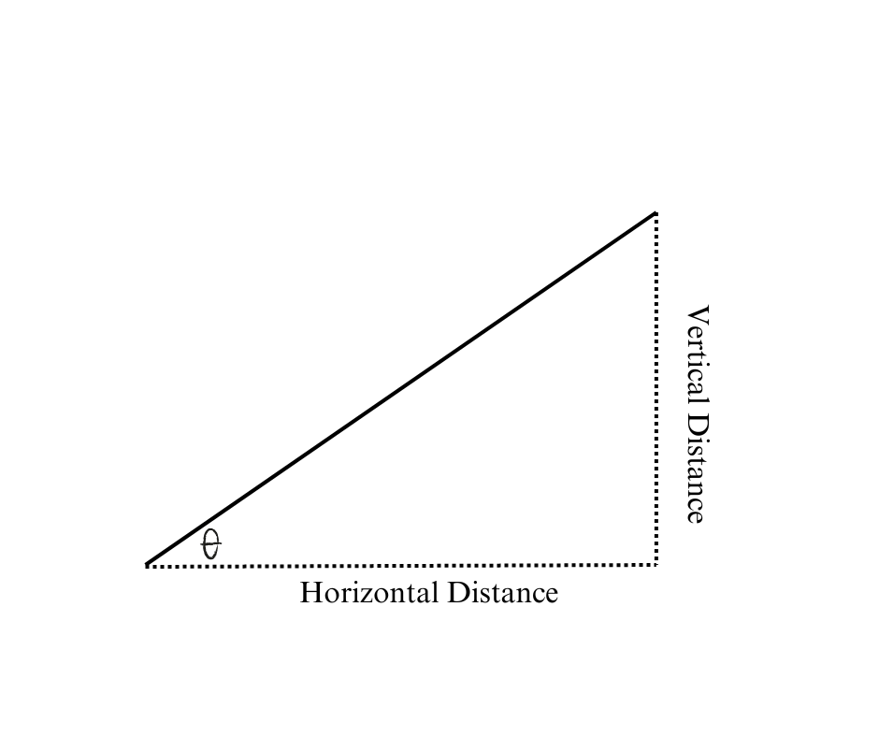

Figure 1: Distance travelled for Climb phase

## Fuel Calculation

For the determination of fuel consumption, specific fuel consumption (sfc) values specific to the engine used in the aircraft were extrapolated from the POH [6], which was then utilized to determine the amount of fuel consumed based on time travelled per phase(t), velocity(V) and power required (Prequired). It can be given by the formula;

|  |  |  |
| --- | --- | --- |
|  | $$Fuel Consumed \left(∆f\right)=sfc×Thrust×time taken=sfc\frac{P_{required}×t}{V}$$ | (18) |

# Aircraft Parameters specific to A320

Parameters required for determination of performance metrics for the A320 aircraft were extrapolated using the data obtained through the manufacturer specific handbook, including POH, AFM, and Maintenance planning manuals [6, 7]. Some of the parameters utilized for the calculation alongside their values specific to the aircraft are as follows;

* Maximum Takeoff Weight = 73900 [kg] [6]
* Maximum Landing Weight = 64500 [kg] [6]
* Operational Empty Weight = 42200 [kg] [6]
* Per Engine Weight = 2300 [kg] [8]
* Fuel Burn Rate Factor = 1.872132 [l/NM] [6]
* Specific Fuel Consumption (SFC)=42.2 [kg/kN.h]
* Fuel Density = 0.785 [kg/l] [6]
* Aspect Ratio (AR) = 10.3 [7] ­
* Wing Planform Area (S) = 122.6 [m2] [7]
* Takeoff decision speed (Vr) = 115 [Knots] [6]
* Standard Rate of Climb (ROC) = 1800 [ft/min][6]
* Cruise Airspeed = Mach 0.62 to 0.70 [6]
* Standard Rate of Descent (ROD) = 1800 [ft/min] [6]
* Target Landing Airspeed = 135 [Knots] [6]

Meanwhile, some values like zero-lift drag coefficient (CD0 = 0.014) were estimated using the values provided fromRaymer [2].

# Results

The obtained at different used defined flight profiles the power profiles and fuel consumption plots can be seen as follows;

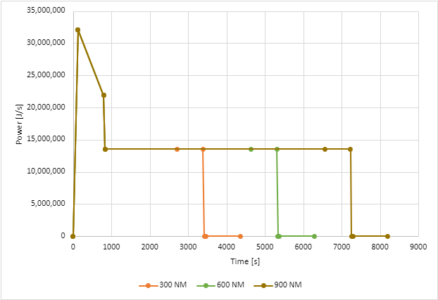

Figure 2: Power Profiles obtained from the formulation

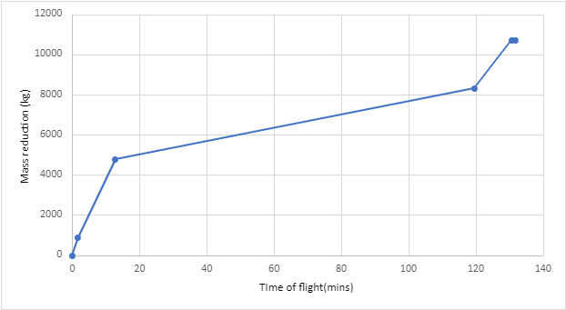

Figure 3: Fuel Consumption trend in terms of fuel mass reduction obtained from the formulation at cruise range of 1000 NM

# References

|  |  |
| --- | --- |
| [1] | J. Roskam, Airplane design. Part I, Preliminary sizing of airplanes, Darcorporation, 2018. |
| [2] | D. P. Raymer, Aircraft design : a conceptual approach, American Institute Of Aeronautics And Astronautics, 2006. |
| [3] | B. N. Pamadi, Performance, stability, dynamics, and control of airplanes, Reston, Va American Institute Of Aeronautics And Astronautics, Inc, 2015. |
| [4] | W. A. Mair and D. L. Birdsall, Aircraft performance, Cambridge Univ. Press, 2003. |
| [5] | J. D. Anderson, Aircraft Performance & Design, McGraw-Hill Science Engineering, 1999. |
| [6] | Airbus, Pilot Operating Handbook And Aircraft Flight Manual for Airbus A320, 2006. |
| [7] | Airbus, "A320 AIRCRAFT CHARACTERISTICS AIRPORT AND MAINTENANCE PLANNING," [Online]. Available: https://www.airbus.com/content/dam/corporate-topics/publications/backgrounders/techdata/aircraft_characteristics/Airbus-Commercial-Aircraft-AC-A320.pdf,. [Accessed 4 5 2024]. |
| [8] | CFM, "The Technology Behind the CFM56-5A Turbofan Engine," CFM, 2010. [Online]. Available: https://web.archive.org/web/20100530091453/http://www.cfm56.com/products/cfm56-5a/cfm56-5a-technology. [Accessed 2024]. |

# Appendix:

The source code corresponding the mathematical framework developed is hosted on GitHub included in the repository below;

<https://github.com/>............

Feedback and suggestions are welcome and greatly appreciated, as it helps improve the project for everyone. Any input from the community will be valued and acknowledged. For any issues, suggestion or request for access feel free to reach out at;

Dipesh Kunwar: [diku@nernst.co](mailto:diku@nernst.co)